**MESD LMS Documentation – Collaborate with another teacher through forum**

**Purpose**

To facilitate with creating a forum by a Senior Educator, adding Educators to that forum and allowing them to collaborate with each other.

**Background**

This module handles requests directly from Educatorswithin the Moodle system, allowing collaboration with other Educators through forums.

**Usage**

**Creating a forum for Educators to use (Senior Educator or higher)**

1. Login as a Senior Educator.
2. Select the *‘Edit mode’* toggle in the upper right to begin editing the course site.
3. Go to ‘My Courses’ > select the course, > *‘Add an activity or resource’*.

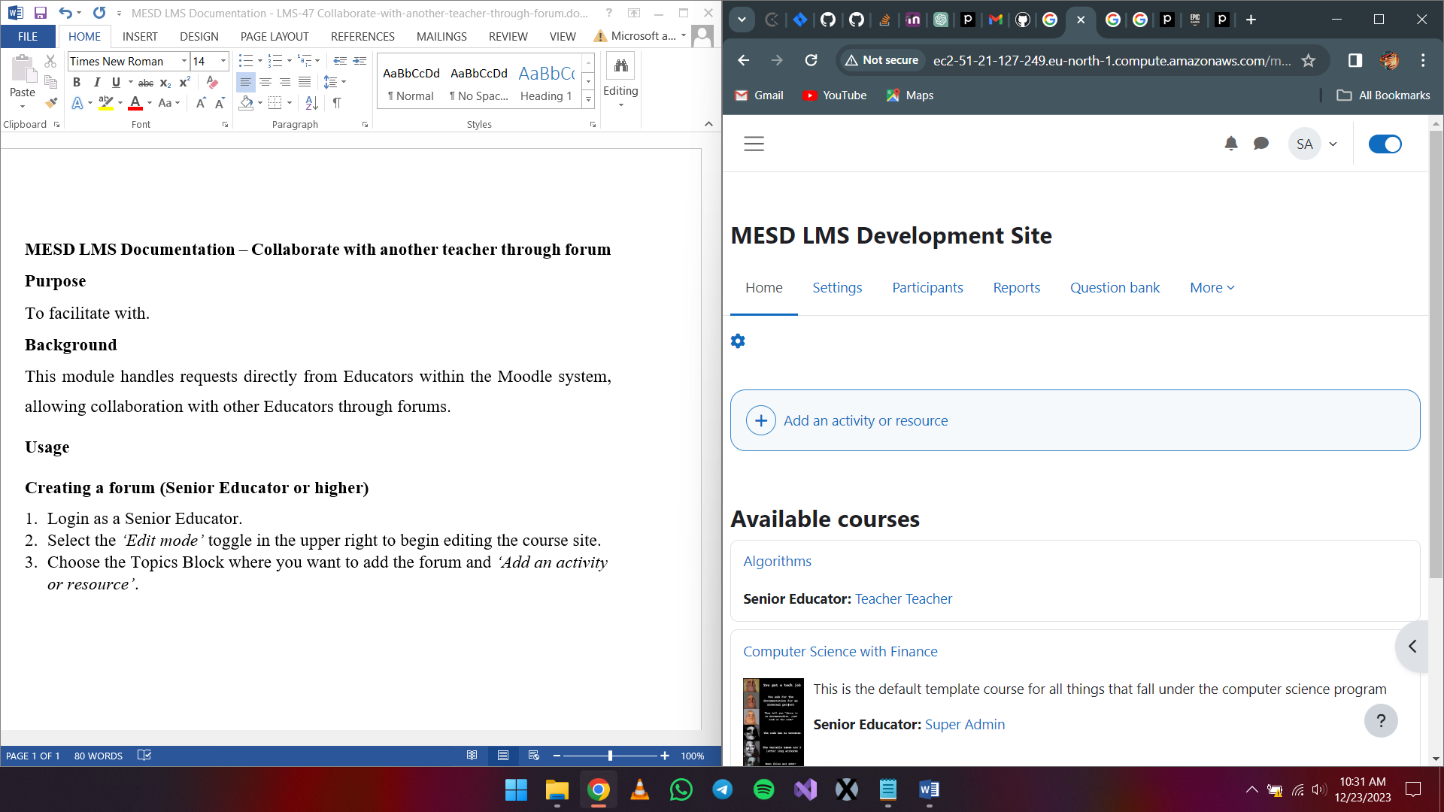

1. Choose forum. Provide a forum name, a description, and set the forum type.
2. Click *‘Save and return to course’.*

Regularly check the forum for new messages or replies. You can also subscribe to the forum to receive email notifications whenever a new post is made.

**Availability and assigning roles**

1. After creating the forum, while in edit mode, click the three dots to view options on that forum.

1. Availability
   1. Click on *‘Availability’* and select if you want learners to view this forum or hide the forum from Learners.

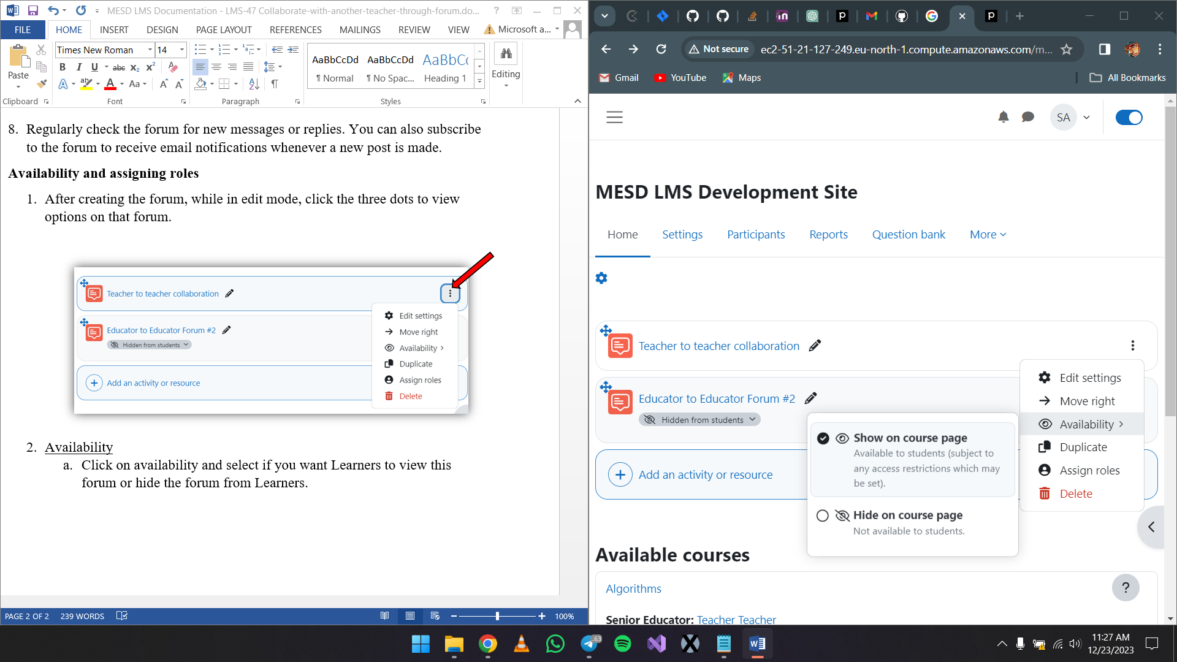

1. Assigning roles
   1. Click on *‘Edit settings’* > *‘Subscriptions’*. Select *‘Manage subscribers’* under the View subscribers dropdown. Select the participants you want to add then click on *‘Add’*.

**Using the forum**

1. Login as an Educator
2. Select the forum to open it
3. Adding a discussion topic
   1. Click on *‘Add discussion topic’*.
   2. Fill in details about the subject and message. When done click *‘Post to forum’*.
4. Deleting a post in a forum
   1. Click the post you created.
   2. Click on the *‘Delete’* button.
   3. When the prompt appears select *‘Continue’*.
5. Editing a post in a forum
   1. Click on the post.
   2. Select *‘Edit’*.
6. Replying to a post in a forum
   1. Click on the post you want to reply to.
   2. Choose *‘Reply’*.
   3. When you get the reply box, enter your message then select ‘Post to forum’ or cancel to end the operation. You can optionally choose to respond privately by ticking the Reply privately box.

